Synopsis Format

|  |  |
| --- | --- |
| Table Of Content | |
| Sr. No. | **Index** |
| 1. | Title of the Project |
| 2. | Introduction |
| 3. | Objective |
| 4. | Project Category |
| 5. | Analysis   * Database Design * ER Diagram * Data Flow Diagram |
| 6. | Complete Structure   * Modules and Description * Process Logical Diagram * Testing |
| 7. | Platform Used   * Hardware Requirement * Software Requirement |
| 8. | Are you doing this project for any client/Industry? If Yes mention name and Address of the Client or Industry |
| 9. | Future Scope |
| 10. | Bibliography |

**Title Of project**

**Online**

**Services Portal**

**Introduction:**

Online Services Portal is a GUI based project which has been developed to provide an environment for complain and manage services of various companies under one place. With the help of this site customers can file their complaint and view current status and action going on their product against their complain.

While employee can receive complain and give update on complain.

On the other hand Administrator can view various complain and action on going those complain. He can check all the details of his employee such as who are working and who are free. And can take manage accordingly.

**Objective:**

This project has been designed to facilitate the consumer of various products for servicing while providing an online environment in which they can easily know the task and action going on product.

The main objectives of this product are as follows:-

1. Remove manual system of maintenance of record.
2. To provide a better online environment for work.
3. To make everything automated which will be fast and time conserving.
4. Flexibility in generating reports and updates.
5. To provide consumer satisfaction.
6. Make everything highly accurate.
7. To create transparency in service management.
8. Provide user a One Place Platform for multiple product service.

**Objective:**

This project has been designed to facilitate the consumer of various products for servicing while providing an online environment in which they can easily know the task and action going on product.

The main objectives of this product are as follows:-

1. Remove manual system of maintenance of record.
2. To provide a better online environment for work.
3. To make everything automated which will be fast and time conserving.
4. Flexibility in generating reports and updates.
5. To provide consumer satisfaction.
6. Make everything highly accurate.
7. To create transparency in service management.
8. Provide user a One Place Platform for multiple product service.

**Project Category:**

**GUI Based Application**

**Database Design:-**

**1. Employee:-**

|  |  |
| --- | --- |
| **Field** | **Type** |
| Emp_ID | Varchar2 |
| Name | Varchar2 |
| Date_Of_Birth | Date |
| Address | Varchar2 |
| Contact | Number |
| Date_Of_Joining | Date |
| Email_ID | Varchar2 |

2. **Login Detail:-**

|  |  |
| --- | --- |
| **Field** | **Type** |
| Emp_ID_User_ID | Varchar2 |
| Password | Varchar2 |
| Role | Varchar2 |

**3. User:-**

|  |  |
| --- | --- |
| **Field** | **Type** |
| User_ID | Varchar2 |
| Name | Varchar2 |
| Date_Of_Birth | Date |
| Address | Varchar2 |
| Contact | Number |
| Email_ID | Varchar2 |

4.  **Complain_list:-**

|  |  |
| --- | --- |
| **Field** | **Type** |
| Complain_id | Varchar2 |
| user_ID | Varchar2 |
| Product_id | Varchar2 |
| issue | Varchar2 |
| Date_of_Complain | Date |
| status | Varchar2 |

**6. service_handling:**

|  |  |
| --- | --- |
| **Field** | **Type** |
| service_ID | Varchar2 |
| Emp_ID | Varchar2 |
| Complain_ID | Varchar2 |
| Date_Of_service | Date |
| Action_Taken | Varchar2 |
| status | Varchar2 |

**7. Product_list:-**

|  |  |
| --- | --- |
| **Field** | **Type** |
| Product_Id | Varchar2 |
| Product_Name | Varchar2 |
| Company Name | Varchar2 |

**8. Feedback:-**

|  |  |
| --- | --- |
| **Field** | **Type** |
| User_ID | Varchar2 |
| Complain_ID | Varchar2 |
| Feedback_Date | Date |
| Remark | Varchar2 |
| Status | Varchar2 |

**9. Department_list**

|  |  |
| --- | --- |
| **Field** | **Type** |
| dept_id | Varchar2 |
| Dept_name | Varchar2 |
| Emp_id | Varchar2 |
| designation | Varchar2 |

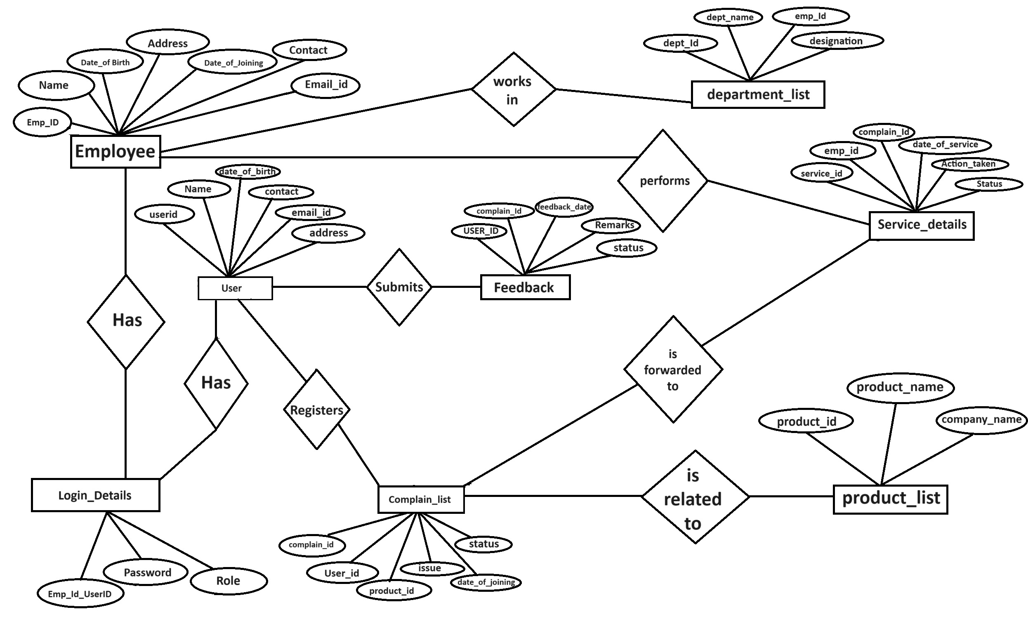

ER-Diagram

Data Flow Diagram